**import** **pandas** **as** **pd**

**from** **matplotlib** **import** pyplot **as** plt

**import** **numpy** **as** **np**

%matplotlib inline

df = pd.read_csv("customer_churn.csv")

df.sample(5)

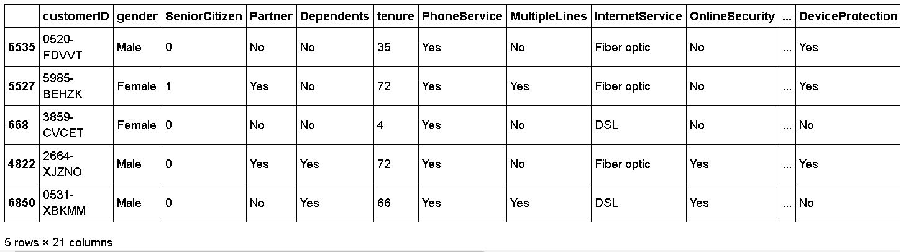

df.drop('customerID',axis='columns',inplace=**True**)

df.dtypes

output:

gender object

SeniorCitizen int64

Partner object

Dependents object

tenure int64

PhoneService object

MultipleLines object

InternetService object

OnlineSecurity object

OnlineBackup object

DeviceProtection object

TechSupport object

StreamingTV object

StreamingMovies object

Contract object

PaperlessBilling object

PaymentMethod object

MonthlyCharges float64

TotalCharges object

Churn object

dtype: object

In [255]:df.TotalCharges.values

Out[255]:

array(['29.85', '1889.5', '108.15', ..., '346.45', '306.6', '6844.5'],

dtype=object)

In [256]:

pd.to_numeric(df.TotalCharges)

In [257]:

pd.to_numeric(df.TotalCharges,errors='coerce').isnull()

Out[257]:

0 False

1 False

2 False

3 False

4 False

...

7038 False

7039 False

7040 False

7041 False

7042 False

Name: TotalCharges, Length: 7043, dtype: bool

In [258]:

df[pd.to_numeric(df.TotalCharges,errors='coerce').isnull()]

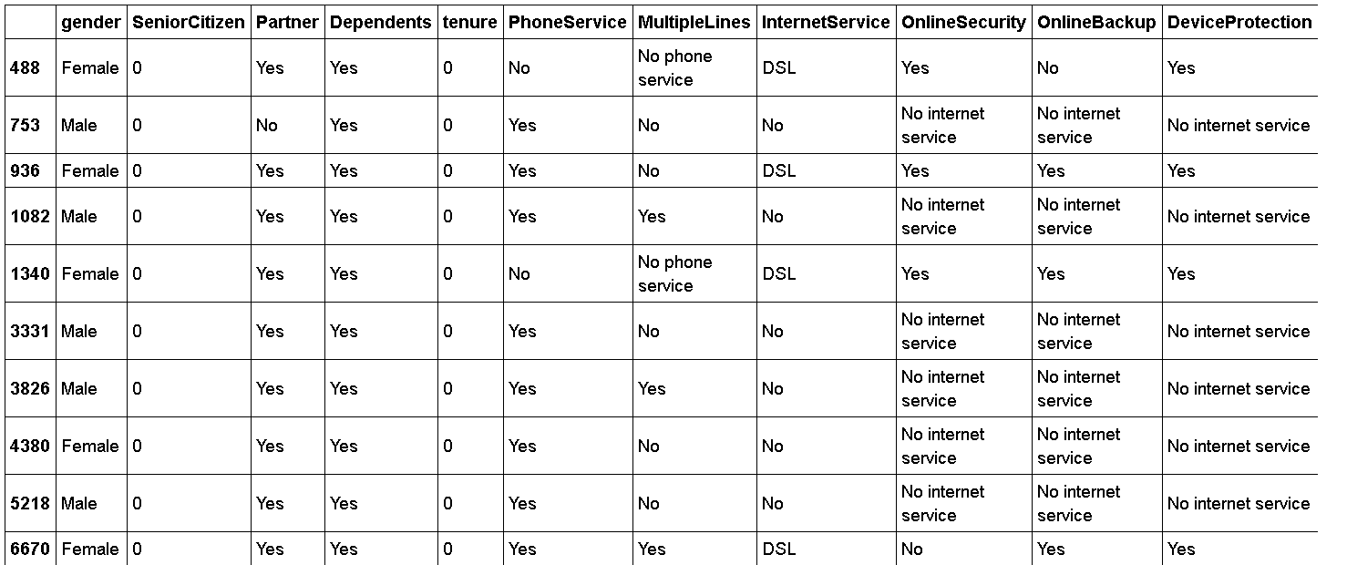

In [259]:

df.shape

Out[259]:

(7043, 20)

In [260]:

df.iloc[488].TotalCharges

Out[260]:

' '

In [261]:

df[df.TotalCharges!=' '].shape

Out[261]:

(7032, 20)

In [262]:

df1 = df[df.TotalCharges!=' ']

df1.shape

Out[262]:

(7032, 20)

In [263]:

df1.dtypes

Out[263]:

gender object

SeniorCitizen int64

Partner object

Dependents object

tenure int64

PhoneService object

MultipleLines object

InternetService object

OnlineSecurity object

OnlineBackup object

DeviceProtection object

TechSupport object

StreamingTV object

StreamingMovies object

Contract object

PaperlessBilling object

PaymentMethod object

MonthlyCharges float64

TotalCharges object

Churn object

dtype: object

In [264]:

df1.TotalCharges = pd.to_numeric(df1.TotalCharges)

C:\Users\dhava\AppData\Roaming\Python\Python38\site-packages\pandas\core\generic.py:5159: SettingWithCopyWarning:

A value is trying to be set on a copy of a slice from a DataFrame.

Try using .loc[row_indexer,col_indexer] = value instead

See the caveats in the documentation: https://pandas.pydata.org/pandas-docs/stable/user_guide/indexing.html#returning-a-view-versus-a-copy

self[name] = value

In [265]:

df1.TotalCharges.values

Out[265]:

array([ 29.85, 1889.5 , 108.15, ..., 346.45, 306.6 , 6844.5 ])

In [266]:

df1[df1.Churn=='No']

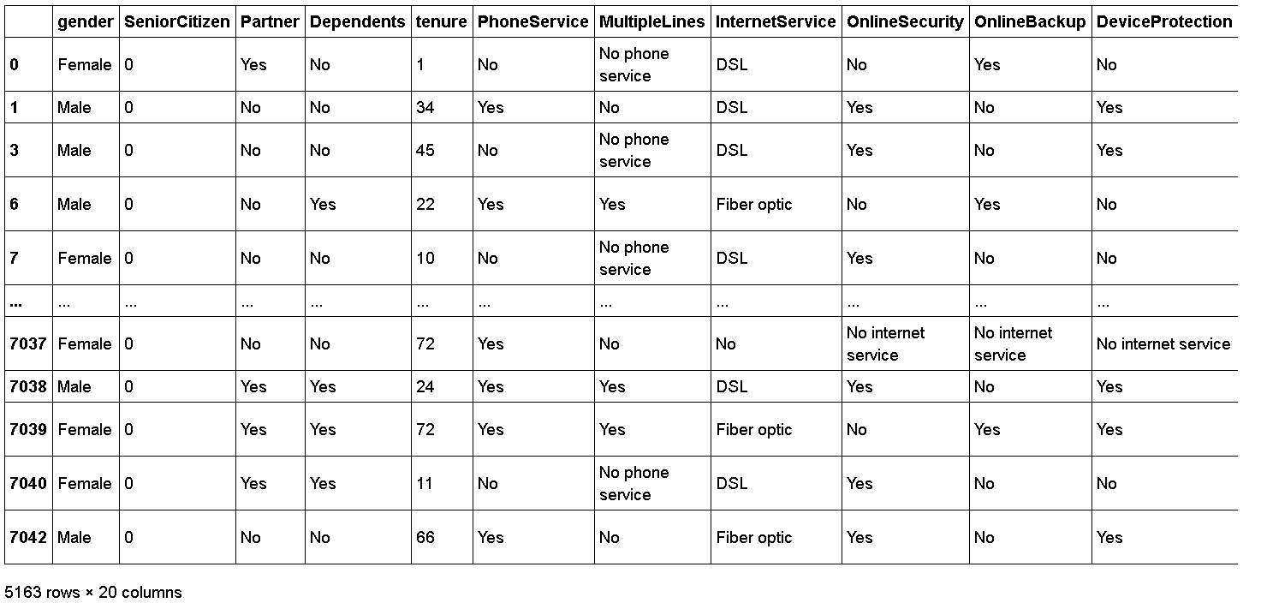

In [271]:

tenure_churn_no = df1[df1.Churn=='No'].tenure

tenure_churn_yes = df1[df1.Churn=='Yes'].tenure

plt.xlabel("tenure")

plt.ylabel("Number Of Customers")

plt.title("Customer Churn Prediction Visualiztion")

blood_sugar_men = [113, 85, 90, 150, 149, 88, 93, 115, 135, 80, 77, 82, 129]

blood_sugar_women = [67, 98, 89, 120, 133, 150, 84, 69, 89, 79, 120, 112, 100]

plt.hist([tenure_churn_yes, tenure_churn_no], rwidth=0.95, color=['green','red'],label=['Churn=Yes','Churn=No'])

plt.legend()

Out[271]:

<matplotlib.legend.Legend at 0x2181d04b700>

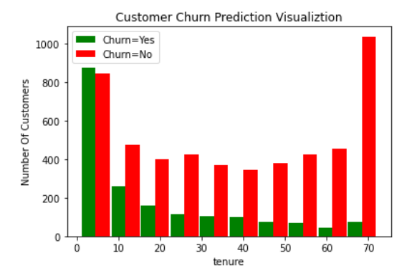

In [272]:

mc_churn_no = df1[df1.Churn=='No'].MonthlyCharges

mc_churn_yes = df1[df1.Churn=='Yes'].MonthlyCharges

plt.xlabel("Monthly Charges")

plt.ylabel("Number Of Customers")

plt.title("Customer Churn Prediction Visualiztion")

blood_sugar_men = [113, 85, 90, 150, 149, 88, 93, 115, 135, 80, 77, 82, 129]

blood_sugar_women = [67, 98, 89, 120, 133, 150, 84, 69, 89, 79, 120, 112, 100]

plt.hist([mc_churn_yes, mc_churn_no], rwidth=0.95, color=['green','red'],label=['Churn=Yes','Churn=No'])

plt.legend()

Out[272]:

<matplotlib.legend.Legend at 0x2181d15fac0>

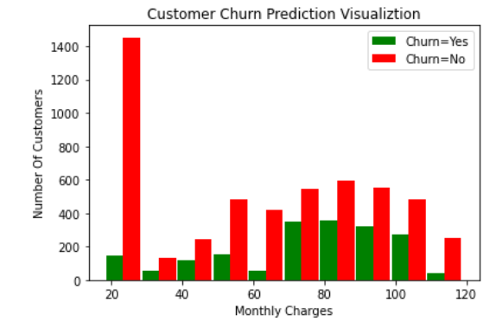

In [143]:

**def** print_unique_col_values(df):

**for** column **in** df:

**if** df[column].dtypes=='object':

print(f'**{**column**}**: **{**df[column].unique()**}**')

In [144]:

print_unique_col_values(df1)

gender: ['Female' 'Male']

Partner: ['Yes' 'No']

Dependents: ['No' 'Yes']

PhoneService: ['No' 'Yes']

MultipleLines: ['No phone service' 'No' 'Yes']

InternetService: ['DSL' 'Fiber optic' 'No']

OnlineSecurity: ['No' 'Yes' 'No internet service']

OnlineBackup: ['Yes' 'No' 'No internet service']

DeviceProtection: ['No' 'Yes' 'No internet service']

TechSupport: ['No' 'Yes' 'No internet service']

StreamingTV: ['No' 'Yes' 'No internet service']

StreamingMovies: ['No' 'Yes' 'No internet service']

Contract: ['Month-to-month' 'One year' 'Two year']

PaperlessBilling: ['Yes' 'No']

PaymentMethod: ['Electronic check' 'Mailed check' 'Bank transfer (automatic)'

'Credit card (automatic)']

Churn: ['No' 'Yes']

In [145]:

df1.replace('No internet service','No',inplace=**True**)

df1.replace('No phone service','No',inplace=**True**)

C:\Users\dhava\AppData\Roaming\Python\Python38\site-packages\pandas\core\frame.py:4373: SettingWithCopyWarning:

A value is trying to be set on a copy of a slice from a DataFrame

See the caveats in the documentation: https://pandas.pydata.org/pandas-docs/stable/user_guide/indexing.html#returning-a-view-versus-a-copy

return super().replace(

In [146]:

print_unique_col_values(df1)

gender: ['Female' 'Male']

Partner: ['Yes' 'No']

Dependents: ['No' 'Yes']

PhoneService: ['No' 'Yes']

MultipleLines: ['No' 'Yes']

InternetService: ['DSL' 'Fiber optic' 'No']

OnlineSecurity: ['No' 'Yes']

OnlineBackup: ['Yes' 'No']

DeviceProtection: ['No' 'Yes']

TechSupport: ['No' 'Yes']

StreamingTV: ['No' 'Yes']

StreamingMovies: ['No' 'Yes']

Contract: ['Month-to-month' 'One year' 'Two year']

PaperlessBilling: ['Yes' 'No']

PaymentMethod: ['Electronic check' 'Mailed check' 'Bank transfer (automatic)'

'Credit card (automatic)']

Churn: ['No' 'Yes']

**Convert Yes and No to 1 or 0**

In [147]:

yes_no_columns = ['Partner','Dependents','PhoneService','MultipleLines','OnlineSecurity','OnlineBackup',

'DeviceProtection','TechSupport','StreamingTV','StreamingMovies','PaperlessBilling','Churn']

**for** col **in** yes_no_columns:

df1[col].replace({'Yes': 1,'No': 0},inplace=**True**)

C:\Users\dhava\AppData\Roaming\Python\Python38\site-packages\pandas\core\series.py:4563: SettingWithCopyWarning:

A value is trying to be set on a copy of a slice from a DataFrame

See the caveats in the documentation: https://pandas.pydata.org/pandas-docs/stable/user_guide/indexing.html#returning-a-view-versus-a-copy

return super().replace(

In [148]:

**for** col **in** df1:

print(f'**{**col**}**: **{**df1[col].unique()**}**')

gender: ['Female' 'Male']

SeniorCitizen: [0 1]

Partner: [1 0]

Dependents: [0 1]

tenure: [ 1 34 2 45 8 22 10 28 62 13 16 58 49 25 69 52 71 21 12 30 47 72 17 27

5 46 11 70 63 43 15 60 18 66 9 3 31 50 64 56 7 42 35 48 29 65 38 68

32 55 37 36 41 6 4 33 67 23 57 61 14 20 53 40 59 24 44 19 54 51 26 39]

PhoneService: [0 1]

MultipleLines: [0 1]

InternetService: ['DSL' 'Fiber optic' 'No']

OnlineSecurity: [0 1]

OnlineBackup: [1 0]

DeviceProtection: [0 1]

TechSupport: [0 1]

StreamingTV: [0 1]

StreamingMovies: [0 1]

Contract: ['Month-to-month' 'One year' 'Two year']

PaperlessBilling: [1 0]

PaymentMethod: ['Electronic check' 'Mailed check' 'Bank transfer (automatic)'

'Credit card (automatic)']

MonthlyCharges: [29.85 56.95 53.85 ... 63.1 44.2 78.7 ]

TotalCharges: [ 29.85 1889.5 108.15 ... 346.45 306.6 6844.5 ]

Churn: [0 1]

In [149]:

df1['gender'].replace({'Female':1,'Male':0},inplace=**True**)

In [150]:

df1.gender.unique()

Out[150]:

array([1, 0], dtype=int64)

**One hot encoding for categorical columns**

In [151]:

df2 = pd.get_dummies(data=df1, columns=['InternetService','Contract','PaymentMethod'])

df2.columns

Out[151]:

Index(['gender', 'SeniorCitizen', 'Partner', 'Dependents', 'tenure',

'PhoneService', 'MultipleLines', 'OnlineSecurity', 'OnlineBackup',

'DeviceProtection', 'TechSupport', 'StreamingTV', 'StreamingMovies',

'PaperlessBilling', 'MonthlyCharges', 'TotalCharges', 'Churn',

'InternetService_DSL', 'InternetService_Fiber optic',

'InternetService_No', 'Contract_Month-to-month', 'Contract_One year',

'Contract_Two year', 'PaymentMethod_Bank transfer (automatic)',

'PaymentMethod_Credit card (automatic)',

'PaymentMethod_Electronic check', 'PaymentMethod_Mailed check'],

dtype='object')

In [152]:

df2.sample(5)

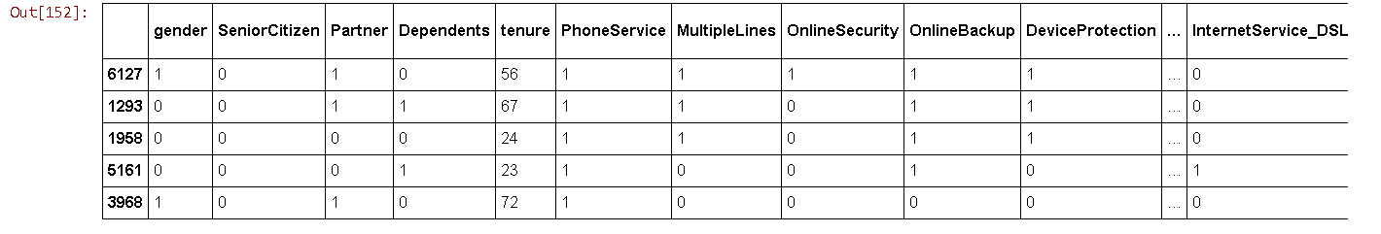

In [153]:

df2.dtypes

Out[153]:

gender int64

SeniorCitizen int64

Partner int64

Dependents int64

tenure int64

PhoneService int64

MultipleLines int64

OnlineSecurity int64

OnlineBackup int64

DeviceProtection int64

TechSupport int64

StreamingTV int64

StreamingMovies int64

PaperlessBilling int64

MonthlyCharges float64

TotalCharges float64

Churn int64

InternetService_DSL uint8

InternetService_Fiber optic uint8

InternetService_No uint8

Contract_Month-to-month uint8

Contract_One year uint8

Contract_Two year uint8

PaymentMethod_Bank transfer (automatic) uint8

PaymentMethod_Credit card (automatic) uint8

PaymentMethod_Electronic check uint8

PaymentMethod_Mailed check uint8

dtype: object

In [154]:

cols_to_scale = ['tenure','MonthlyCharges','TotalCharges']

**from** **sklearn.preprocessing** **import** MinMaxScaler

scaler = MinMaxScaler()

df2[cols_to_scale] = scaler.fit_transform(df2[cols_to_scale])

In [160]:

**for** col **in** df2:

print(f'**{**col**}**: **{**df2[col].unique()**}**')

gender: [1 0]

SeniorCitizen: [0 1]

Partner: [1 0]

Dependents: [0 1]

tenure: [0. 0.46478873 0.01408451 0.61971831 0.09859155 0.29577465

0.12676056 0.38028169 0.85915493 0.16901408 0.21126761 0.8028169

0.67605634 0.33802817 0.95774648 0.71830986 0.98591549 0.28169014

0.15492958 0.4084507 0.64788732 1. 0.22535211 0.36619718

0.05633803 0.63380282 0.14084507 0.97183099 0.87323944 0.5915493

0.1971831 0.83098592 0.23943662 0.91549296 0.11267606 0.02816901

0.42253521 0.69014085 0.88732394 0.77464789 0.08450704 0.57746479

0.47887324 0.66197183 0.3943662 0.90140845 0.52112676 0.94366197

0.43661972 0.76056338 0.50704225 0.49295775 0.56338028 0.07042254

0.04225352 0.45070423 0.92957746 0.30985915 0.78873239 0.84507042

0.18309859 0.26760563 0.73239437 0.54929577 0.81690141 0.32394366

0.6056338 0.25352113 0.74647887 0.70422535 0.35211268 0.53521127]

PhoneService: [0 1]

MultipleLines: [0 1]

OnlineSecurity: [0 1]

OnlineBackup: [1 0]

DeviceProtection: [0 1]

TechSupport: [0 1]

StreamingTV: [0 1]

StreamingMovies: [0 1]

PaperlessBilling: [1 0]

MonthlyCharges: [0.11542289 0.38507463 0.35422886 ... 0.44626866 0.25820896 0.60149254]

TotalCharges: [0.0012751 0.21586661 0.01031041 ... 0.03780868 0.03321025 0.78764136]

Churn: [0 1]

InternetService_DSL: [1 0]

InternetService_Fiber optic: [0 1]

InternetService_No: [0 1]

Contract_Month-to-month: [1 0]

Contract_One year: [0 1]

Contract_Two year: [0 1]

PaymentMethod_Bank transfer (automatic): [0 1]

PaymentMethod_Credit card (automatic): [0 1]

PaymentMethod_Electronic check: [1 0]

PaymentMethod_Mailed check: [0 1]

**Train test split**

In [161]:

X = df2.drop('Churn',axis='columns')

y = df2['Churn']

**from** **sklearn.model_selection** **import** train_test_split

X_train, X_test, y_train, y_test = train_test_split(X,y,test_size=0.2,random_state=5)

In [162]:

X_train.shape

Out[162]:

(5625, 26)

In [163]:

X_test.shape

Out[163]:

(1407, 26)

In [207]:

X_train[:10]

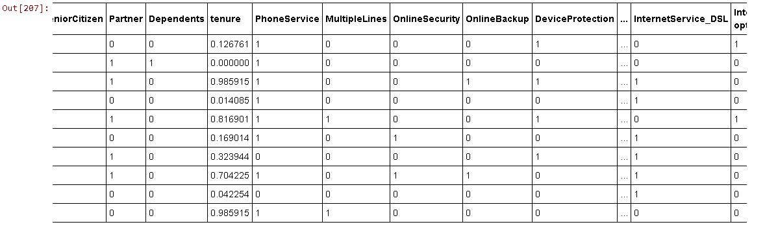

In [166]:

len(X_train.columns)

Out[166]:

26

In [208]:

**import** **tensorflow** **as** **tf**

**from** **tensorflow** **import** keras

model = keras.Sequential([

keras.layers.Dense(26, input_shape=(26,), activation='relu'),

keras.layers.Dense(15, activation='relu'),

keras.layers.Dense(1, activation='sigmoid')

])

*# opt = keras.optimizers.Adam(learning_rate=0.01)*

model.compile(optimizer='adam',

loss='binary_crossentropy',

metrics=['accuracy'])

model.fit(X_train, y_train, epochs=100)

In [29]:

encoding_dim = 32

*# this is our input placeholder*

input_img = Input(shape=(input_shape,))

*# "encoded" is the encoded representation of the input*

encoded = Dense(encoding_dim, activation='relu')(input_img)

*# "decoded" is the lossy reconstruction of the input*

decoded = Dense(input_shape, activation='sigmoid')(encoded)

*# this model maps an input to its reconstruction*

autoencoder = Model(inputs=input_img, outputs=decoded)

In [30]:

autoencoder.compile(optimizer='adadelta', loss='binary_crossentropy') *#optimizer = adam --- can also be used*

In [31]:

autoencoder.fit(X_train, X_train,

epochs=50,

batch_size=24,

shuffle=True,

validation_data=(X_test, X_test))

model2 = Sequential()

model2.add(Dense(64, input_dim = 32, kernel_initializer='uniform', activation='relu'))

model2.add(Dropout(0.2))

model2.add(Dense(16, activation='relu'))

model2.add(Dropout(0.2))

model2.add(Dense(1, kernel_initializer='uniform', activation='sigmoid'))

In [38]:

model2.compile(loss='binary_crossentropy',

optimizer='Adam',

metrics=['accuracy'])